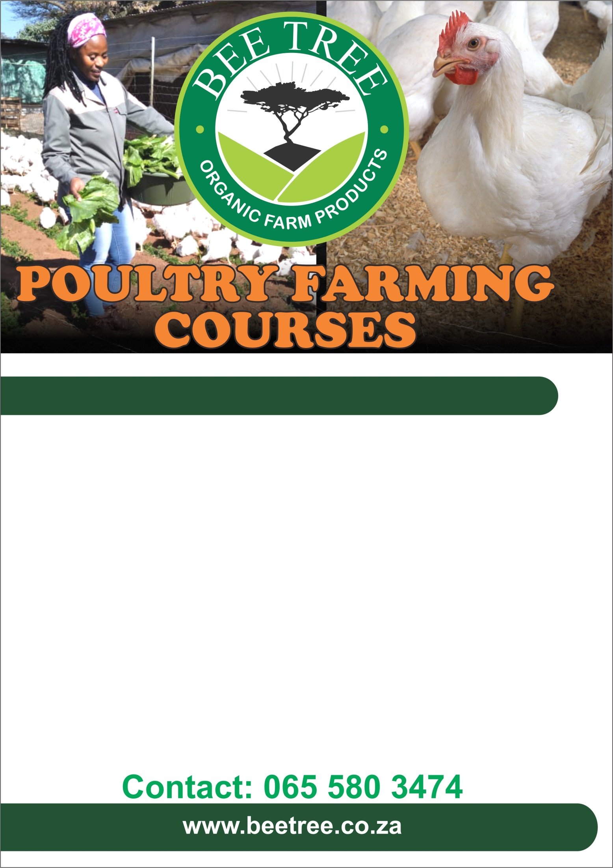
This training workshop will focus on the following topics:
How to identify and select the right breed of layer chickens for farming needs
Construct and manage a brooder for the chics
Housing requirements for the layers
Diseases management and prevention
Record keeping for profitable layer farming
Soil preparation using organic methods
Marketing your eggs

This course is suitable for anyone who would like to start a profitable business in layer production.

Date: 3 February 2024
Time: 9am - 5pm
Venue: Bee Tree Farm

Cost R1500
(Incl. Coffee, Farm lunch, Practical’s, Training module and Certificate of attendance)
Layers chicken farming Workshop

